**Final exam review 3**

**True or False**

1. None is the same as False in Python.

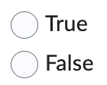

1. The finally block in Python is designed to execute code that should always run, regardless of whether an exception was raised in the try block.



1. “==” and “is” are interchangeable in Python.



1. The break statement can only be used in while loops.



1. The else block in a loop is executed only if a break statement terminates the loop.



1. The “with” statement is used to handle files and automatically closes them.



1. Python raises a FileNotFoundError if a file opened in 'w' mode does not exist.



1. The readlines() method reads a file and returns a list of lines.



**Short Answer Questions**

Q. Write a Python program to find the sum of all elements in a list.

Q. What is the output of the following code? Explain why?

x = [1, 2, 3]

y = x

y.append(4)

print(x)

Q. Write a Python program to check if a string is a palindrome.

Q. What is the output of the following code?

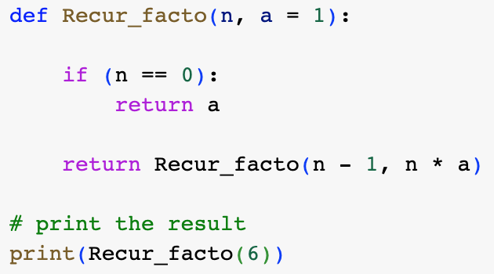

Q. Suppose the file “data.csv” exists on your computer containing data shown below. What will be the output in the console if you run the below code?

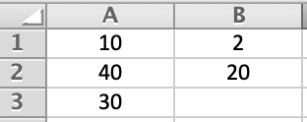

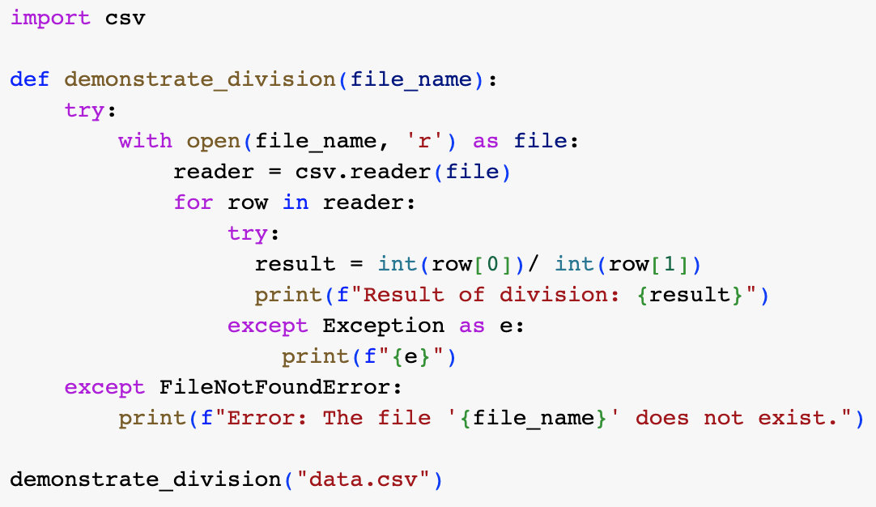

Q. Create a Python function iterates over the set of questions, asks each question, checks the user's answer, and keeps track of the score.

The below set contains tuples, each with a question and its corresponding correct answer:

quiz = {

("What is the capital of Italy?", "Rome"),

("What is 50 + 250?", "300"),

("What is the largest planet in our solar system?", "Jupiter"),

("Who wrote 'A thousand splendid sun'?", "Khaled Hosseini"),

("What is the chemical symbol for water?", "H2O")

}

**The program’s output is shown below**

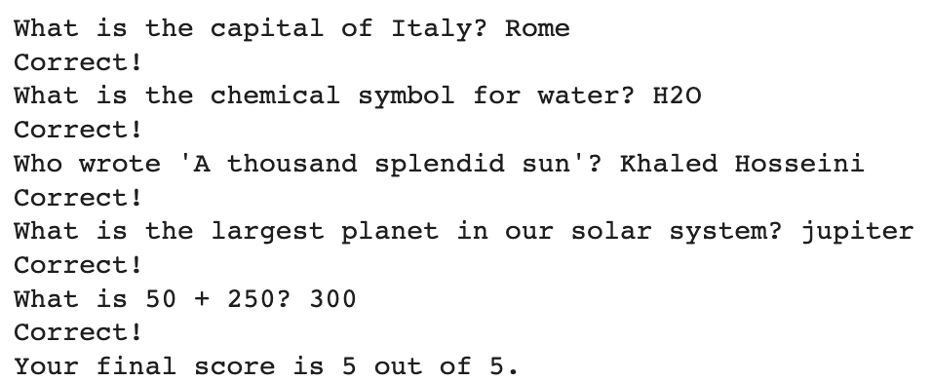

Q. Write a program to create a unique list from the sample list:

sample\_list = [1, 2, 2, 3, 4, 4, 5, 6, 6, 7, 8, 8,9, 10,10]

**The program’s output is shown below**

Macintosh HD:private:var:folders:np:d_nnl6yd0wx7x9zlknd34nvh0000gn:T:TemporaryItems:Screen Shot 2024-11-25 at 3.07.44 PM.png

Q. Write a program using format strings so that the results are properly aligned as follows. Use input() to get first and second integer.

**The program’s output is shown below**

